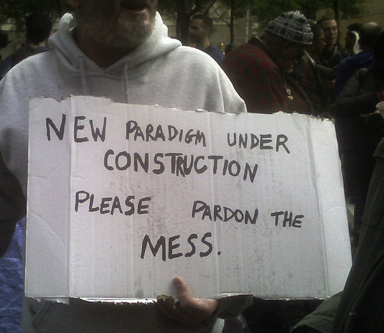

May 31-June 2, 2012

20 Cooper Square 5th floor, New York NY, 10012

## Workshops, digital skills, lightning talks, performances, OWS video festival, publications, speed writing, more….

## keynotes, more….

# A participation event for

# the International Association for Visual Culture

# the

Now! Visual Culture

E: nm45[at]nyu.edu

* NYU more follows….